Paper Title Authors & affiliation example:

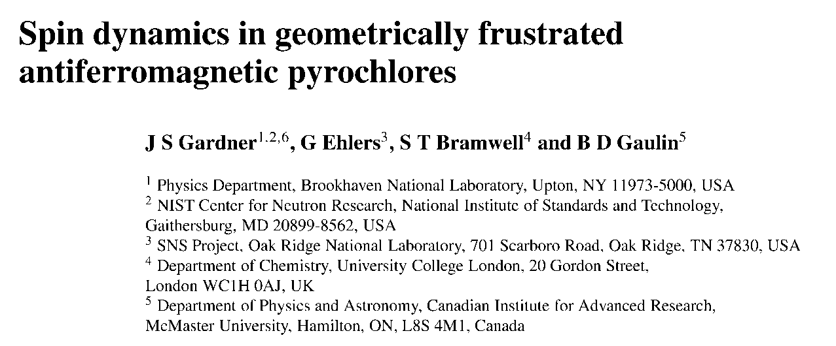

**Keywords:**

**Abstract.** All articles *must* contain an abstract.The abstract text should be formatted using 10 point Times or Times New Roman and indented 25 mm from the left margin. Leave 10 mm space after the abstract before you begin the main text of your article, starting on the same page as the abstract. The abstract should give readers concise information about the content of the article and indicate the main results obtained and conclusions drawn. The abstract is not part of the text and should be complete in itself; no table numbers, figure numbers, references or displayed mathematical expressions should be included. It should be suitable for direct inclusion in abstracting services and should not normally exceed 200 words in a single paragraph. Since contemporary information-retrieval systems rely heavily on the content of titles and abstracts to identify relevant articles in literature searches, great care should be taken in constructing both.

1. Introduction

These guidelines show the proposed layout for your paper using Microsoft Word. If you don’t wish to use the Word template provided, please use the following page setup measurements. Page limit is 6 including references.

|  |  |
| --- | --- |
| Margin | **A4 ONLY – DO NOT USE US LETTER** |
| Top | 4.0 cm |
| Bottom | 2.7 cm |
| Left | 2.5 cm |
| Right | 2.5 cm |
| Gutter | 0 cm |
| Header | 0 cm |
| Footer | 0 cm |

1. Formatting the text

The text of your paper should be formatted as follows:

* 11 point Times or Times New Roman.
* The text should be set to single line spacing.
* Paragraphs should be justified.

1. Sections, subsections and subsubsections

The use of sections to divide the text of the paper is optional and left as a decision for the author. Where the author wishes to divide the paper into sections the formatting shown in table 2 should be used.

* 1. Style and spacing

|  |  |  |
| --- | --- | --- |
| **Table 2.** Formatting sections, subsections and subsubsections. | | |
|  | Font | Spacing |
| Section | 11 point **Times bold** | 1 line space before a section  No additional space after a section heading |
| Subsection | 11 point *Times Italic* | 1 line space before a subsection  No space after a subsubsection heading |
| Subsubsection | 11 point *Times Italic* | Subsubsections should end with a full stop (period) and run into the text of the paragraph |

* 1. Numbering

Sections should be numbered with a dot following the number and then separated by a single space:

* sections should be numbered 1, 2, 3, etc
* subsections should be numbered 2.1, 2.2, 2.3, etc
* subsubsections should be numbered 2.3.1, 2.3.2, etc

1. Footnotes

Footnotes should be avoided whenever possible. If required they should be used only for brief notes that do not fit conveniently into the text.

1. Figures

Each figure should have a brief caption describing it and, if necessary, a key to interpret the various lines and symbols on the figure.

Text in figures

Wherever possible try to ensure that the size of the text in your figures (apart from superscripts/subscripts) is approximately the same size as the main text (11 points).

Colour illustrations

You are free to use colour.

Figure captions/numbering

Captions should be below the figure. Figures should be numbered sequentially through the text—‘Figure 1’, ‘Figure 2’ and so forth and should be referenced in the text as ‘figure 1’, ‘figure 2’,… and not ‘fig. 1’, ‘fig. 2’, ….

For captions not placed at the side of the figure, captions should be set to the width of the figure for wider figures, centred across the width of the figure, or, for narrow figures with wide captions, slightly extended beyond the width of the figure. The caption should finish with a full stop (period).

Figures in parts

If a figure has parts these should be labelled as (a), (b), (c) etc on the actual figure. Parts should not have separate captions.

1. Tables

Note that as a general principle, for large tables font sizes can be reduced to make the table fit on a page or fit to the width of the text.

Positioning tables

Tables should be centred unless they occupy the full width of the text.

Tables in parts

If a table is divided into parts these should be labelled (a), (b), (c) etc but there should only be one caption for the whole table, not separate ones for each part.

Table captions/numbering

Tables should be numbered sequentially throughout the text and referred to in the text by number (table 1, **not** tab. 1 etc). Captions should be placed at the top of the table and should have a full stop (period) at the end. Except for very narrow tables with a wide caption (see examples below) the caption should be the same width as the table.

Rules in tables

Tables should have only horizontal rules and no vertical ones. Generally, only three rules should be used: one at the top of the table, one at the bottom, and one to separate the entries from the column headings. Table rules should be 0.5 points wide.

1. Equations and mathematics

Fonts in Equation Editor (or MathType)

Make sure that your Equation Editor or MathType fonts, including sizes, are set up to match the text of your document.

Vectors. Bold italic characters is our preferred style but the author may use any standard notation; for example, any of these styles for vectors is acceptable:

‘the vector cross product of ***a*** and ***b*** is given by …’, or

‘the vector cross product of **a** and **b** is given by …’, or

‘the vector cross product of and is given by …’

*The solidus* (). A two-line solidus should be avoided where possible; for example, use

* instead of 
*  instead of 

Roman and italic in mathematics. Variables should be in italic; however there are some cases where it is better to use a Roman font:

* Use a Roman d for a differential d, for example, 
* Use a Roman e for an exponential e; for example, 
* Use a Roman i for the square root of –1; e.g., 
* Certain other common mathematical functions, such as cos, sin, det and ker, should appear in Roman type.
* Subscripts and superscripts should be in Roman type if they are labels rather than variables or characters that take values. For example in the equation



*m*, the *z* component of the nuclear spin, is italic because it can have different values whereas n is Roman because it is a label meaning nuclear.

Alignment of mathematics

Small displayed equations: Some examples:

 (1)

 (2)

However, if equations will fit on one line, do so; for example, (5) may also be formatted as:

 (6)

Large display equations: examples. If an equation is almost the width of a line, place it flush left against the margin to allow room for the equation number.

 (7)

Miscellaneous points

* Exponential expressions, especially those containing subscripts or superscripts, are clearer if the notation  is used, except for simple examples. For instance, and  are preferred to and  but is acceptable. Similarly the square root sign  should only be used with relatively simple expressions, e.g. and  but in other cases the power should be used.
* It is important to distinguish between and 
* Braces, brackets and parentheses should be used in the following order: {[()]}. The same ordering of brackets should be used within each size. However, this ordering can be ignored if the brackets have a special meaning (e.g. if they denote an average or a function).
* Decimal fractions should always be preceded by a zero: for example 0.123 *not* .123 (note, do not use commas, use the decimal point).
* Equations that are referred to in the text should be numbered with the number on the right-hand side.

Equation numbering

Equations may be numbered sequentially throughout the text (i.e., (1), (2), (3),…) or numbered by section (i.e., (1.1), (1.2), (2.1) ,…) depending on the author’s personal preference. In articles with several appendices equation numbering by section is useful in the appendices even when sequential numbering has been used throughout the main body of the text: for example, A.1, A.2 and so forth. When referring to an equation in the text, always put the equation number in brackets—e.g. ‘as in equation (2)’ or ‘as in equation (2.1)’—and always spell out the word ‘equation’ in full, e.g. ‘if equation (5) is factorized’; do not use abbreviations such as ‘eqn.’ or ‘eq.’.

1. Appendices

Technical detail that it is necessary to include, but that interrupts the flow of the article, may be consigned to an appendix. Any appendices should be included at the end of the main text of the paper, after the acknowledgments section (if any) but before the reference list. If there are two or more appendices they should be called appendix A, appendix B, etc. Numbered equations should be in the form (A.1), (A.2), etc, figures should appear as figure A1, figure B1, etc and tables as table A1, table B1, etc.

1. Acknowledgments

Authors wishing to acknowledge assistance or encouragement from colleagues, special work by technical staff or financial support from organizations should do so in an unnumbered Acknowledgments section immediately following the last numbered section of the paper.

1. References
2. Abbreviations of the names of periodicals are the same as those given in British Standard BS 4148: 1985. If an author is unsure of an abbreviation it is best to leave the title in full. The terms *loc. cit.* and *ibid* should not be used.

Unpublished conferences and reports should generally not be included in the reference list and articles in the course of publication should be entered only if the journal of publication is known. A thesis submitted for a higher degree may be included in the reference list if it has not been superseded by a published paper and is available through a library; sufficient information should be given for it to be traced readily.

**Font size 9. It is *vitally* important for all the references to be accurate and to be carefully formatted using the guidelines below, otherwise delays may be incurred and the references may not link through Mendeley or similar**. A complete reference should provide the reader with enough information to locate the article concerned, whether published in print or electronic form, and should, depending on the type of reference, consist of:

* name(s) and initials;
* date published;
* title of journal, book or other publication;
* titles of journal articles may also be included (optional);
* volume number;
* editors, if any;
* town of publication and publisher in parentheses for *books*;
* the page numbers.

Here are some examples:

Journal papers:

[1] P. Koukouvinis, C. Rodriguez, J. Hwang, I. Karathanassis, M. Gavaises, L. Pickett ‘Machine Learning and supercritical sprays: a demonstration study of their potential in ECN Spray-A’, Int J Engine Research, <https://doi.org/10.1177/14680874211020292>

Conference papers:

[2] P. Pfeiffer, I. Karathanassis, Y. Fan, F. Reuter, T. Sato, J. Koliyadu, Š. Birnšteinová, N. Taulier, S. Cherkaoui, C.-D. Ohl, C. Contino-Pépin, P. Vagovič and M. Gavaises ‘Visualization of microbubbles in an artificial blood stream exposed to ultrasound using ultra high-speed X-ray imaging’, ESRF Dynamics meets synchrotron X-ray high-speed imaging, Grenoble, France, 21-22 March 2024

Thesis and Reports

[3] M. Gavaises ‘Modelling of Diesel Fuel Injection Processes’, PhD Thesis, Imperial College London, UK, 1997

Books and Book Chapters

[4] I. Karathanassis, P. Koukouvinis, M. Gavaises ‘Multiphase Phenomena in Diesel Fuel Injection Systems’, book chapter pp 95-126, [Simulations and Optical Diagnostics for Internal Combustion Engines](https://link.springer.com/book/10.1007/978-981-15-0335-1) Springer, 2019; DOI: [10.1007/978-981-15-0335-1_8](http://dx.doi.org/10.1007/978-981-15-0335-1_8)

[5] Cavitation and Bubble Dynamics: Fundamentals and Applications’, Elsevier Academic Press, 2021; eBook ISBN: 9780128233986. Editors: Phoevos Koukouvinis, Manolis Gavaises